- Simulate the following Network. Find the total number of packets transmitted and received.

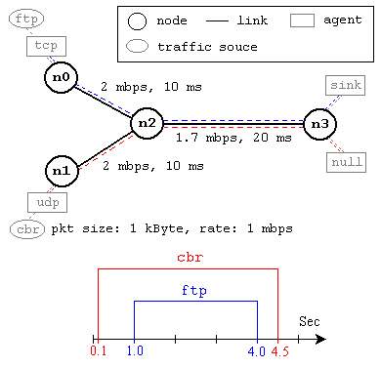
- Sources: no and n1
- Destination: n3
- Total simulation time: 5 sec
- Interface Queue type: Droptail
- CBR Traffic from n1 to n3, started at 0.1 sec and stopped at 4.5sec
- FTP traffic from n0 to n3, started at 1 sec and stopped at 4 sec.

- Construct the following wired network topologies and display these topologies in NAM.
- Linear topology with 10 nodes
- Grid topology with 25 nodes
- Ring topology with 6 nodes
- Star topology with 6 nodes
- Bus topology with 10 nodes

Total simulation time is 50sec. Initiate 2 different transmissions (either CBR or FTP) between randomly selected source and destination. Data transfer is started at 1sec and stopped at 49sec. Measure PDR, PLR and end-to-end delay at equal time interval (10sec, 20, 30, 40 and 50sec) and plot the measured value.

